Dissertation dev log
Week 9:
Current Goals for prototype session:
- A working way of profiling the results of the prototype
- A Critical Review of current technology is completed, that highlights where the gap in research is, and the how this project fills it.
- Readme that highlights development roadmap
- Project is ethically robust
- Profiling results that are easily replicated and are well documented.
- Project plan with gantt chard
Current Strech goals for prototype:
- Fracture implemented in both OpenGL and Vulkan
- Voronoi clipping implemented
- A way to interact with the fragmented mesh
- An implementation in GLSL, for performance comparison
Completed:
- A working Voronoi fracture in 2D for demonstration
- Working Voronoi fracture in 3D
- Comprehensive background done, covering triangulation, fracturing methods used in games, Graphics API’s, Performance of Graphics API’s, Point sampling, and Voronoi Clipping.
- Clearly stated research question
- Clear, feasible hypothesis, that is well scoped.
- An introduction that provides clear context for the project, and explains the need for the research, including positive impacts and who benefits. It should also highlight the motivation for the project.
- Professional, ethical, sustainable, legal, and social review carried out.
- A plan for security and privacy concerns has been written, and data is well managed.
- A methodology for how the project is going to be researched, and how its going to be evaluated

Development notes:
Vulkan implementation is finished, just need to convert Voronoi class to use the new interface. Completed my methodology. A challenge was deciding statistical testing method to use. I resolved this by looking at the stats website, and identifying what my depended, and independent variables were. Im my case, the depended was the performance time I am measuring, and the independent, was my API, which consists of 2 levels, as I’m using OpenGL and Vulkan. My depended variable is also interval. This lead me to conclude that the Wilcoxon-Mann Whitney test is most appropriate. Started work on my computing artefact section. Ive also completed my g*power test, and concluded I need 145 samples.

Images:
Class Diagram

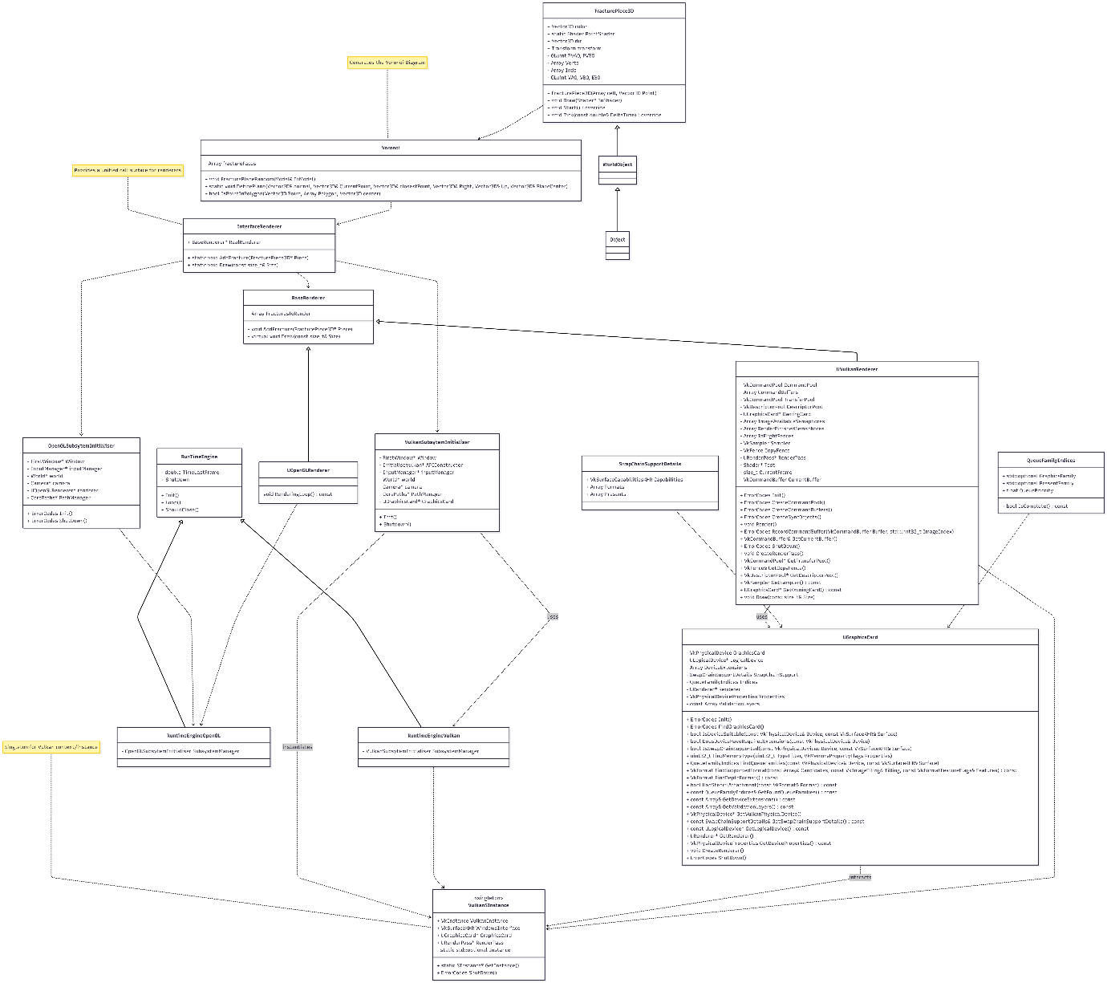
Flow chart of Voronoi diagram generation

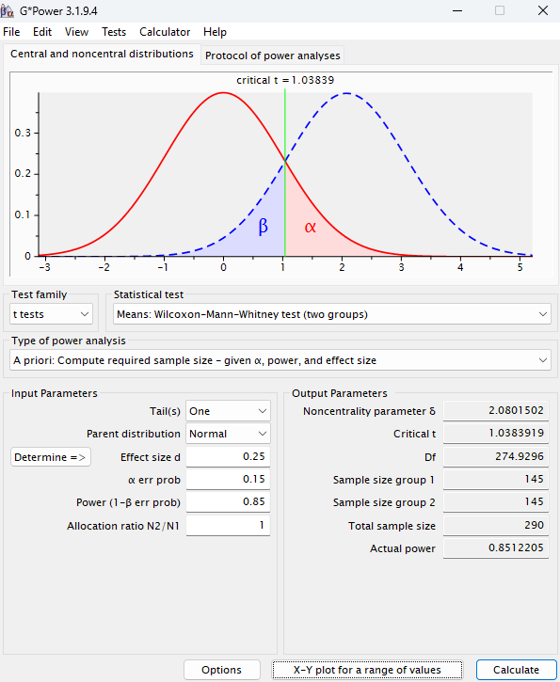
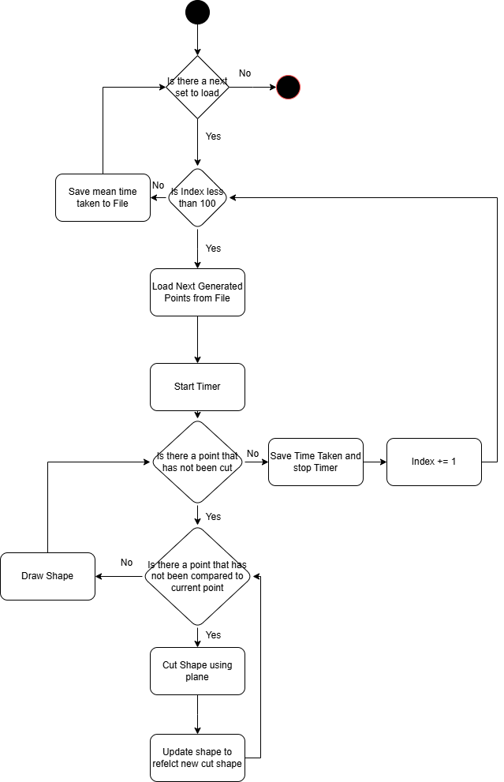

References:

